**Jméno**: **Daniel Slowik** **Třída: 2.C Datum: 26.4.2019**

|  |
| --- |
| Evaluation  **%** |

2.

**Otázka- téma:**

**Tři zajímavé úvodní věty k tématu:**

1. Czech's education system is governed by the Ministry of Education.

číslo otázky

25

2. Children may enter kindergarden at the age of 3.

3. Elementary school consists of nine grades grouped into two stages

**Dvacet vhodných a tématu týkajících se slovíček 20 vhodných, zajímavých slovíček** :

|  |  |  |  |  |
| --- | --- | --- | --- | --- |
| first stage | second stage | exam | teacher | assistant |
| university | gymnasium | holidays | principal | education |
| breaks | friends | certificate | cleaning lady | practice |
| entrance examination | dean | kindergarden | engineer | student |

**Vytvořte větu:**

**-větu v přítomném čase:** I study in Havířov.

**-v předpřítomném čase:** I have written the entrance exams.

**-v minulém čase:** My primary school was built 95 years ago.

**-podmínkovou větu:** If students want to study at university, they have to pass the entrance exams.

**Uveďte tři zajímavá souvětí k tématu:**

1. Education of our language is circuitous, because it has many rules.

2. Schools are usually funded by the state through the budget of the Ministry of Education and that’s why we don’t need to pay for a school.

3. There are three main types of high schools in the Czech Republic, because everyone likes something else

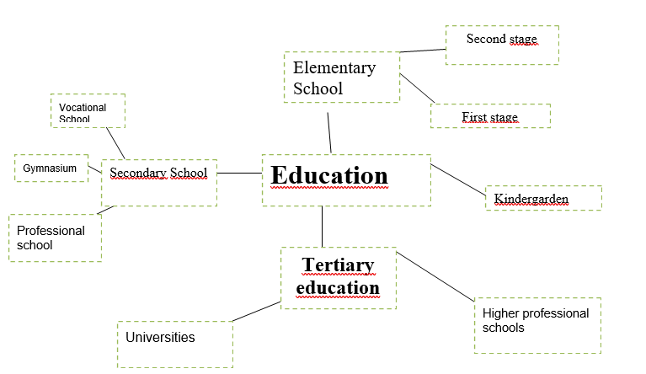

**Mind map:**